Technical Design for Camera System

Revision History

Issue | Date | Person | Reason
0.1 | April 08, 2002 | Cary Brisebois | Creation
1.0 | April 12, 2002 | Cary Brisebois | Reviewed by team and released

Description

Introduction
The camera system for SRR 2 is based on the camera system in SRR 1 with a few enhancements to facilitate expansion and effects. This year instead of a single class called Supercam, there is a manager system that switches control between different instances of Supercams. This document describes the hierarchy and relationships between systems using the Supercams. The technical design for the individual instances of Supercams not defined here.

Requirements
The camera system requires:
- support for multiple camera styles
- support for multiple targets in a view
- support debugging the active camera
- support toggling between camera modes smoothly

References
- Talked to Joe McGinn about design requirements
- See \\depot\documents\design\Preliminary_Design\Camera.thm
- Talked to Eric Honsch about camera systems

Technical Design

Relationships
The Supercam Central is the controller for the various camera modes available in the game. Supercam Central is responsible for:
- lifespan of the camera modes;
- switching control of the player view’s camera between different camera modes;
- responding to system events intended for the cameras
- updating the active camera
- setting camera targets

On initialization, the Supercam Central for a given avatar will retrieve the player view of the avatar and attach to the tCamera the active Supercam.

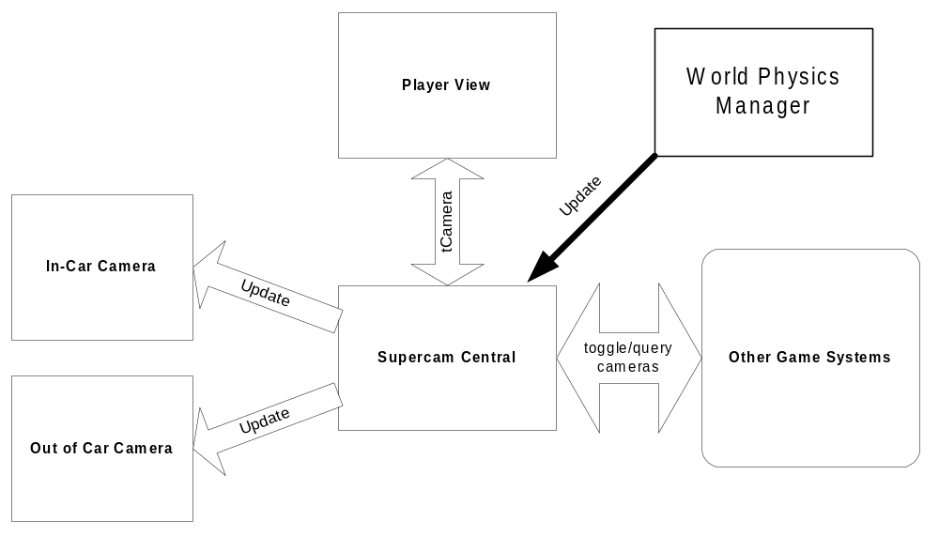Overview of communication between Supercam Cenral and other systems

Class Definitions
class ISuperCamTarget
{
public:
ISuperCamTarget();
virtual ~ISuperCamTarget();

virtual void GetPosition( rmt::Vector* position ) = 0;
virtual void GetHeading( rmt::Vector* heading ) = 0;
virtual void GetVelocity( rmt::Vector* velocity ) = 0;
virtual bool IsCar() = 0;
virtual bool IsAirborn() = 0;
virtual bool IsUnstable() = 0;
};

The IsuperCamTarget class is an interface that objects inherit if they want to be the target of a camera. For example, the player car and walking characters need to inherit this interface.

class SuperCam
{
public:
enum Type
{
STATIC_TRACKING, //Stationary camera that watches a moving target.
STATIC_FOLLOW, //Camera that keeps a relative position from target

//Add cameras before here!
NUM_TYPES,
INVALID = NUM_TYPES
};

SuperCam();
virtual ~SuperCam();

//Update: Called when you want the supercam to update its state.
virtual void Update( unsigned int milliseconds ) = 0;

//Returns the name of the supercam.
//This can be used in the FE or debug info
virtual const char* const GetName() const = 0;

//These functions are to allow real-time control of the settings of
//the supercam.
virtual void RegisterDebugControls() = 0;
virtual void UnregisterDebugControls() = 0;

//This loads the off-line created settings for the camera.
//It is passed in as a byte stream of some data of known size.
virtual void LoadSettings( unsigned char* settings ) = 0;

//These are for favourable support of adding targets
virtual void SetTarget( ISuperCamTarget* target );
virtual void AddTarget( ISuperCamTarget* target );

//Questions other objects can ask of the SuperCam;
//These shouldn't be overloaded.
void GetPosition( rmt::Vector* position ) const;
void GetHeading( rmt::Vector* heading ) const;
void GetVelocity( rmt::Vector* velocity ) const;
void GetCameraUp( rmt::Vector* up ) const;
tCamera* const GetCamera() const;
const Type GetType() const;

//These will override any chnages to the camera if they are set directly
//on the tCamera. They are applied to the tCamera when the SuperCam is
//updated.
void SetFOV( float FOVinRadians );
float GetFOV() const; //Returns value in degrees
void SetAspect( float aspect );
float GetAspect() const;
void SetNearPlane( float nearPlane );
float GetNearPlane() const;
void SetFarPlane( float farPlane );
float GetFarPlane() const;

protected:

//Call this when you want to update the camera. Sets VUP and test for
//bad camera settings.
void SetCameraValues( rmt::Vector pos,
rmt::Vector targ,
const rmt::Vector* vup = 0 );

friend class SuperCamCentral;
//Only SuperCamCentral should call this.
void SetCamera( tPointCamera* cam );

Type mType;
rmt::Vector mVelocity;
tPointCamera* mCamera;

float mFOV; //This is in RADIANS
float mAspect;
float mNearPlane;
float mFarPlane;

char* mName;

private:
rmt::Vector UpdateVUP( rmt::Vector position, rmt::Vector target );
void TestCameraMatrix();
};

This is the base class for all Supercams. Any camera mode available to the game must inherit this class.

class SuperCamCentral
{
public:
enum { MAX_CAMERAS = 10 };

SuperCamCentral();
virtual ~SuperCamCentral();

void Init();

//Update the active super camera
void Update( unsigned int milliseconds );

//Adding and removing available cameras
void RegisterSuperCam( SuperCam* cam );
void UnregisterSuperCam( SuperCam* cam );

//Selecting which cam to make active
bool ToggleSuperCam( bool forwards );
void SelectSuperCam( unsigned int which = 0 );

//How to retrieve the active camera
SuperCam* GetActiveSuperCam();

//This defines what tCamera class is used with all the SuperCams
void SetCam( tPointCamera* cam );
tCamera* const GetCam();

void SetTarget( ISuperCamTarget* target );
void AddTarget( ISuperCamTarget* target );
const ISuperCamTarget* const GetTarget() const;

//Debugging stuff
void ToggleDebugView( bool on = true );

private:
void SetActiveSuperCam( unsigned int which = 0);

void DrawFrustrum();

std::vector<SuperCam*> mSuperCameras;
SuperCam* mActiveSuperCam;

//Things to share between SuperCams
tPointCamera* mCamera;
ISuperCamTarget* mTarget;

static unsigned char mTotalSuperCamCentrals;
unsigned char mMyNumber;

//Debugging stuff.
bool mDebugViewOn;
tPointCamera* mDebugCamera;
};

Component Class Diagrams
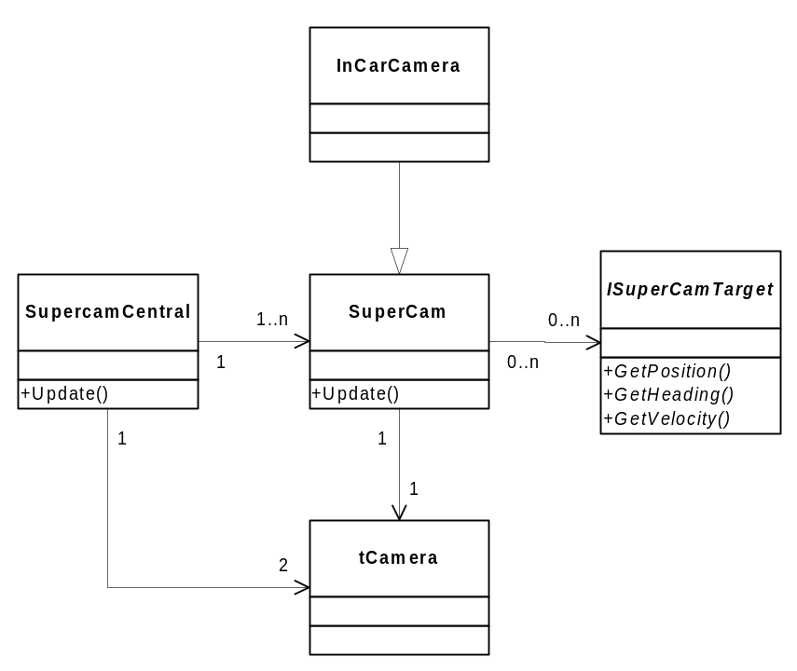
Heirarchy diagram of Supercam Central and associated classes

The Supercam Central will take a tCamera and assign it to its registered supercams. The Supercams in turn will update the tCamera every frame to reflect changes in position, etc. Supercams will use objects that inherit the IsuperCamTarget interface as targets for watching.

The SuperCam central has a pointer to two tCameras because one is the players view and the other is a debugging system camera that allows real-time viewing of what the ingame camera is doing.

Use Cases

Supercam Central Initialization
- Register Supercam instances
- Get tCamera from player view
- Assign tCamera to registered Supercams
- Assign target(s) to Supercam Central
- Assign target(s) to registered Supercams
- Select initial Supercam
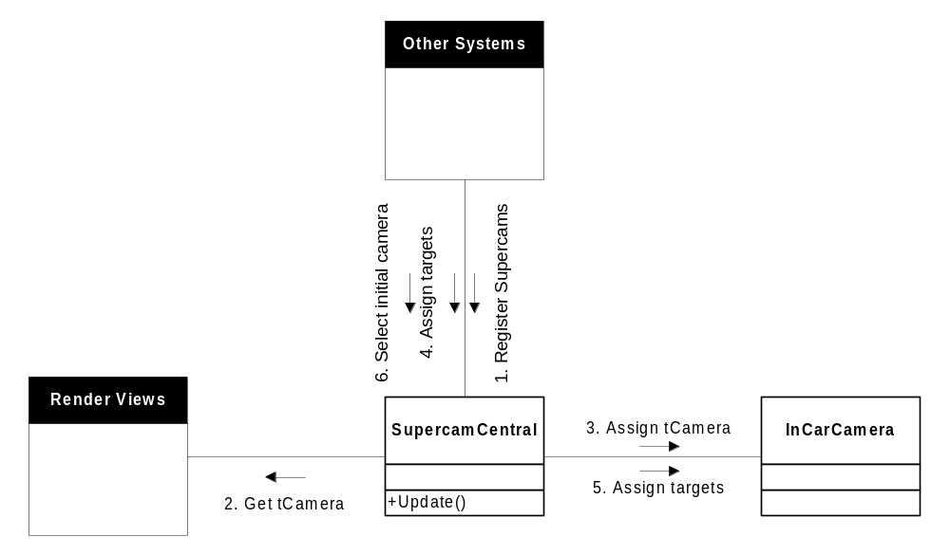Collaboration between Supercam Central and other systems during Init

Update Active Supercam
- Update Supercam Central with time delta
- Update active Supercam with time delta
- Get target state (if applicable)
- Update tCamera with new data (position / target)

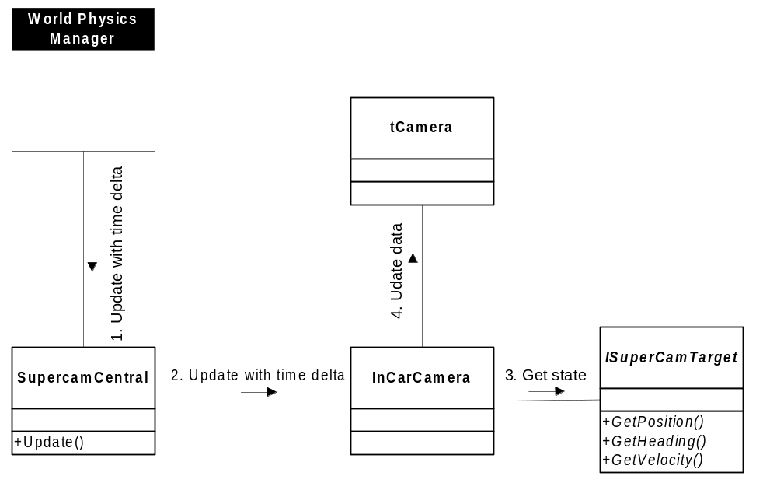
Collaboration for updating active Supercam

